Psalm 22 – A Song of VICTORY
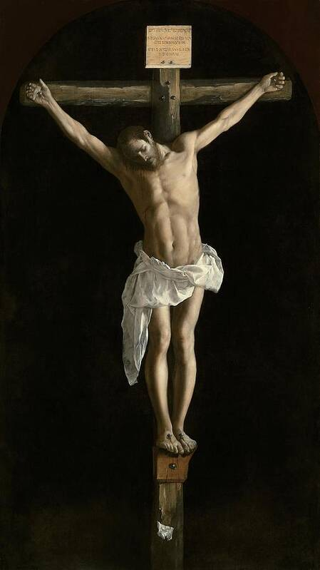

Crucified Christ by Diego Velazquez (c. 1632)

My God, my God, why have you abandoned me? Why so far from my call for help, from my cries of anguish? My God, I call by day, but you do not answer; by night, but I have no relief.
Matthew 27:46-48 And about three o’clock Jesus cried out in a loud voice, “Eli, Eli, lema sabachthani?”* which means, “My God, my God, why have you forsaken me?” Some of the bystanders who heard it said, “This one is calling for Elijah.” Immediately, one of them ran to get a sponge; he soaked it in wine, and putting it on a reed, gave it to him to drink.
Yet you are enthroned as the Holy One; you are the glory of Israel. In you our fathers trusted; they trusted, and you rescued them. To you they cried out, and they escaped; in you they trusted and were not disappointed.
But I am a worm, not a man, scorned by men, despised by the people. All who see me mock me; they curl their lips and jeer; they shake their heads at me: “He relied on the LORD—let him deliver him; if he loves him, let him rescue him.”
Matthew 27:29-30 Those passing by reviled him, shaking their heads and saying, “You who would destroy the temple and rebuild it in three days, save yourself, if you are the Son of God, and come down from the cross!” Likewise, the chief priests with the scribes and elders mocked him and said, “He saved others; he cannot save himself. So, if he is the king of Israel let him come down from the cross now, and we will believe in him. He trusted in God; let him deliver him now if he wants him. For he said, ‘I am the Son of God.’” (Matthew 27:39-43)
Weaving a crown out of thorns, they placed it on his head and a reed in his right hand. And kneeling before him, they mocked him, saying, “Hail, King of the Jews!” They spat upon him and took the reed and kept striking him on the head.
For you drew me forth from the womb, made me safe at my mother’s breasts. Upon you I was thrust from the womb; since my mother bore me, you are my God. Do not stay far from me, for trouble is near, and there is no one to help.
Many bulls surround me; fierce bulls of Bashan encircle me. They open their mouths against me, lions that rend and roar.
Like water, my life drains away; all my bones are disjointed. My heart has become like wax; it melts away within me. As dry as a potsherd is my throat; my tongue cleaves to my palate; you lay me in the dust of death.
John 19:28 After this, aware that everything was now finished, in order that the scripture might be fulfilled,* Jesus said, “I thirst.”
Dogs surround me; a pack of evildoers closes in on me. They have pierced my hands and my feet; I can count all my bones. They stare at me and gloat; they divide my garments among them; for my clothing they cast lots.
John 19:23-24 When the soldiers had crucified Jesus, they took his clothes and divided them into four shares, a share for each soldier. They also took his tunic, but the tunic was seamless, woven in one piece from the top down. So they said to one another, “Let’s not tear it, but cast lots for it to see whose it will be,” in order that the passage of scripture might be fulfilled [that says]: “They divided my garments among them, and for my vesture they cast lots.”
But you, LORD, do not stay far off; my strength, come quickly to help me. Deliver my soul from the sword, my life from the grip of the dog. Save me from the lion’s mouth, my poor life from the horns of wild bulls.
Then I will proclaim your name to my brethren; in the assembly I will praise you: “You who fear the LORD, give praise!
All descendants of Jacob, give honor; show reverence, all descendants of Israel! For he has not spurned or disdained the misery of this poor wretch, did not turn away from me, but heard me when I cried out.
I will offer praise in the great assembly; my vows I will fulfill before those who fear him. The poor will eat their fill; those who seek the LORD will offer praise. May your hearts enjoy life forever!”
All the ends of the earth will remember and turn to the LORD; All the families of nations will bow low before him. For kingship belongs to the LORD, the ruler over the nations.
All who sleep in the earth will bow low before God; All who have gone down into the dust will kneel in homage. And I will live for the LORD; my descendants will serve you.
The generation to come will be told of the Lord, that they may proclaim to a people yet unborn the deliverance you have brought.
Ë Ë Ë

Acts of the Apostles 13:27-34 The inhabitants of Jerusalem and their leaders failed to recognize him, and by condemning him they fulfilled the oracles of the prophets that are read sabbath after sabbath. For even though they found no grounds for a death sentence, they asked Pilate to have him put to death, and when they had accomplished all that was written about him, they took him down from the tree and placed him in a tomb. But God raised him from the dead, and for many days he appeared to those who had come up with him from Galilee to Jerusalem. These are now his witnesses before the people. We ourselves are proclaiming this good news to you that what God promised our ancestors he has brought to fulfillment for us, their children, by raising up Jesus, as it is written in the second psalm, ‘You are my son; this day I have begotten you.’ And that he raised him from the dead never to return to corruption, he declared in this way, ‘I shall give you the benefits assured to David.’”
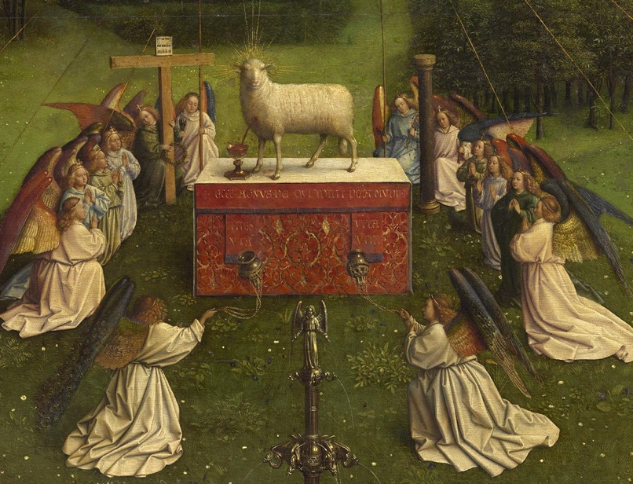
Revelation 5:6 Then I saw a Lamb, looking as if it had been slain, standing at the center of the throne, encircled by the four living creatures and the elders.

